Firas Aboushamalah

250 920 750

CS 2209 Assignment #3

Robert Mercer

QUESTION 1

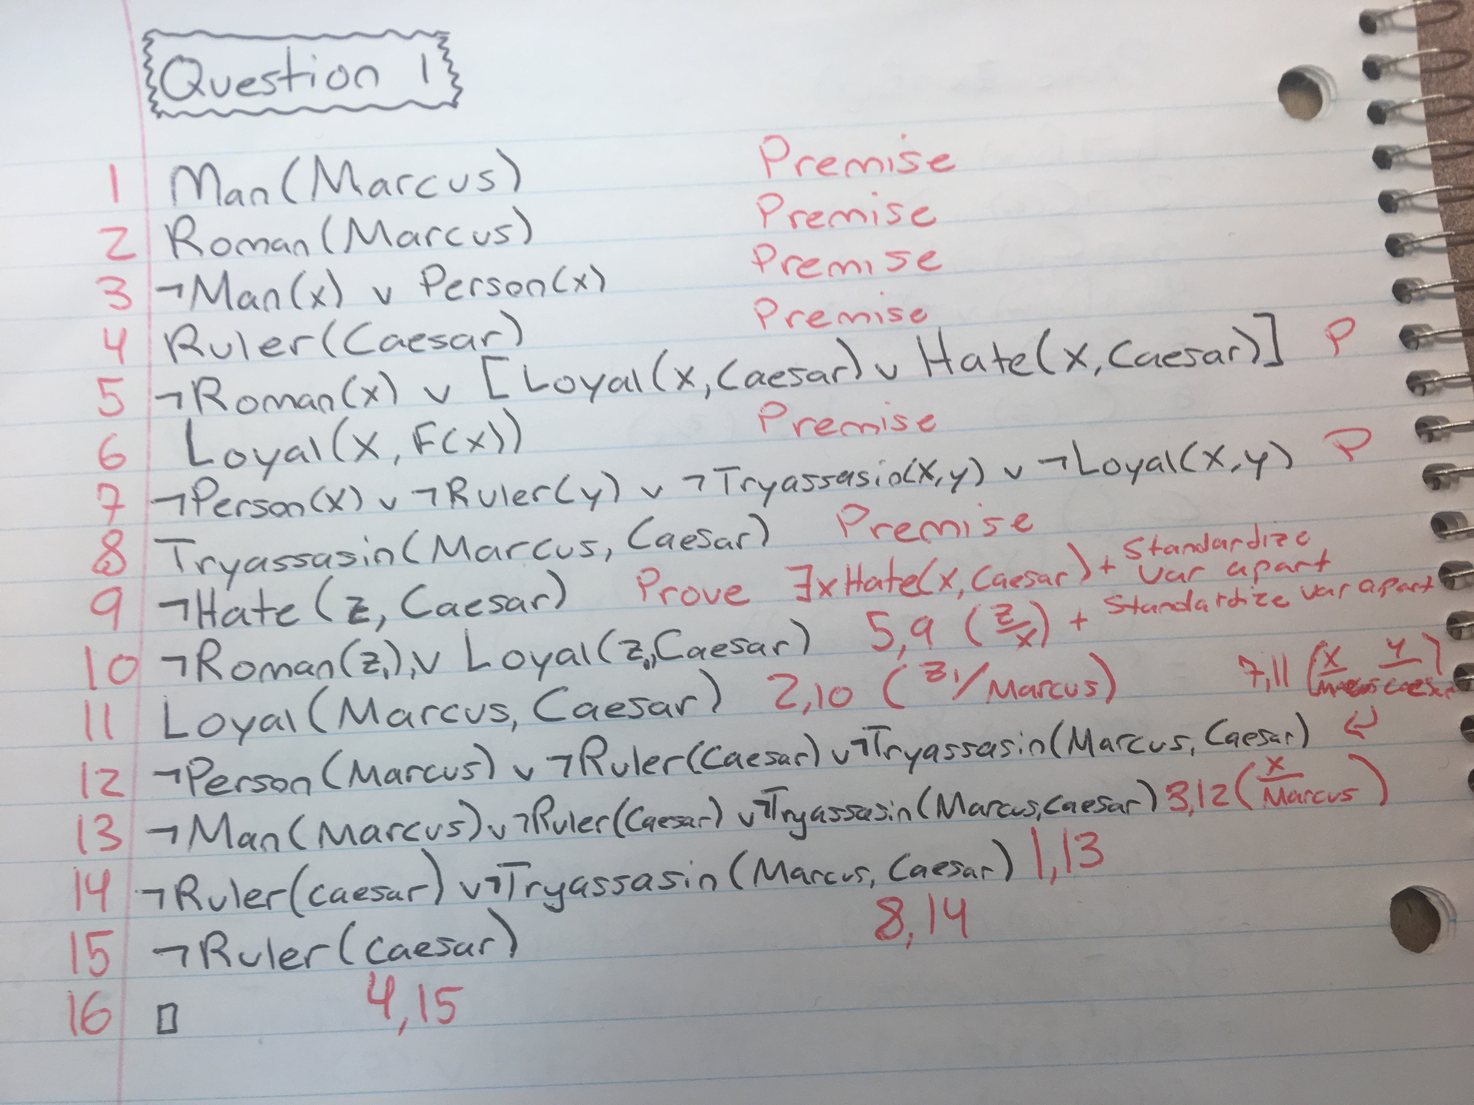

Question 2

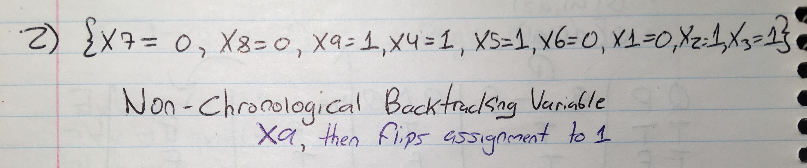

Question 3

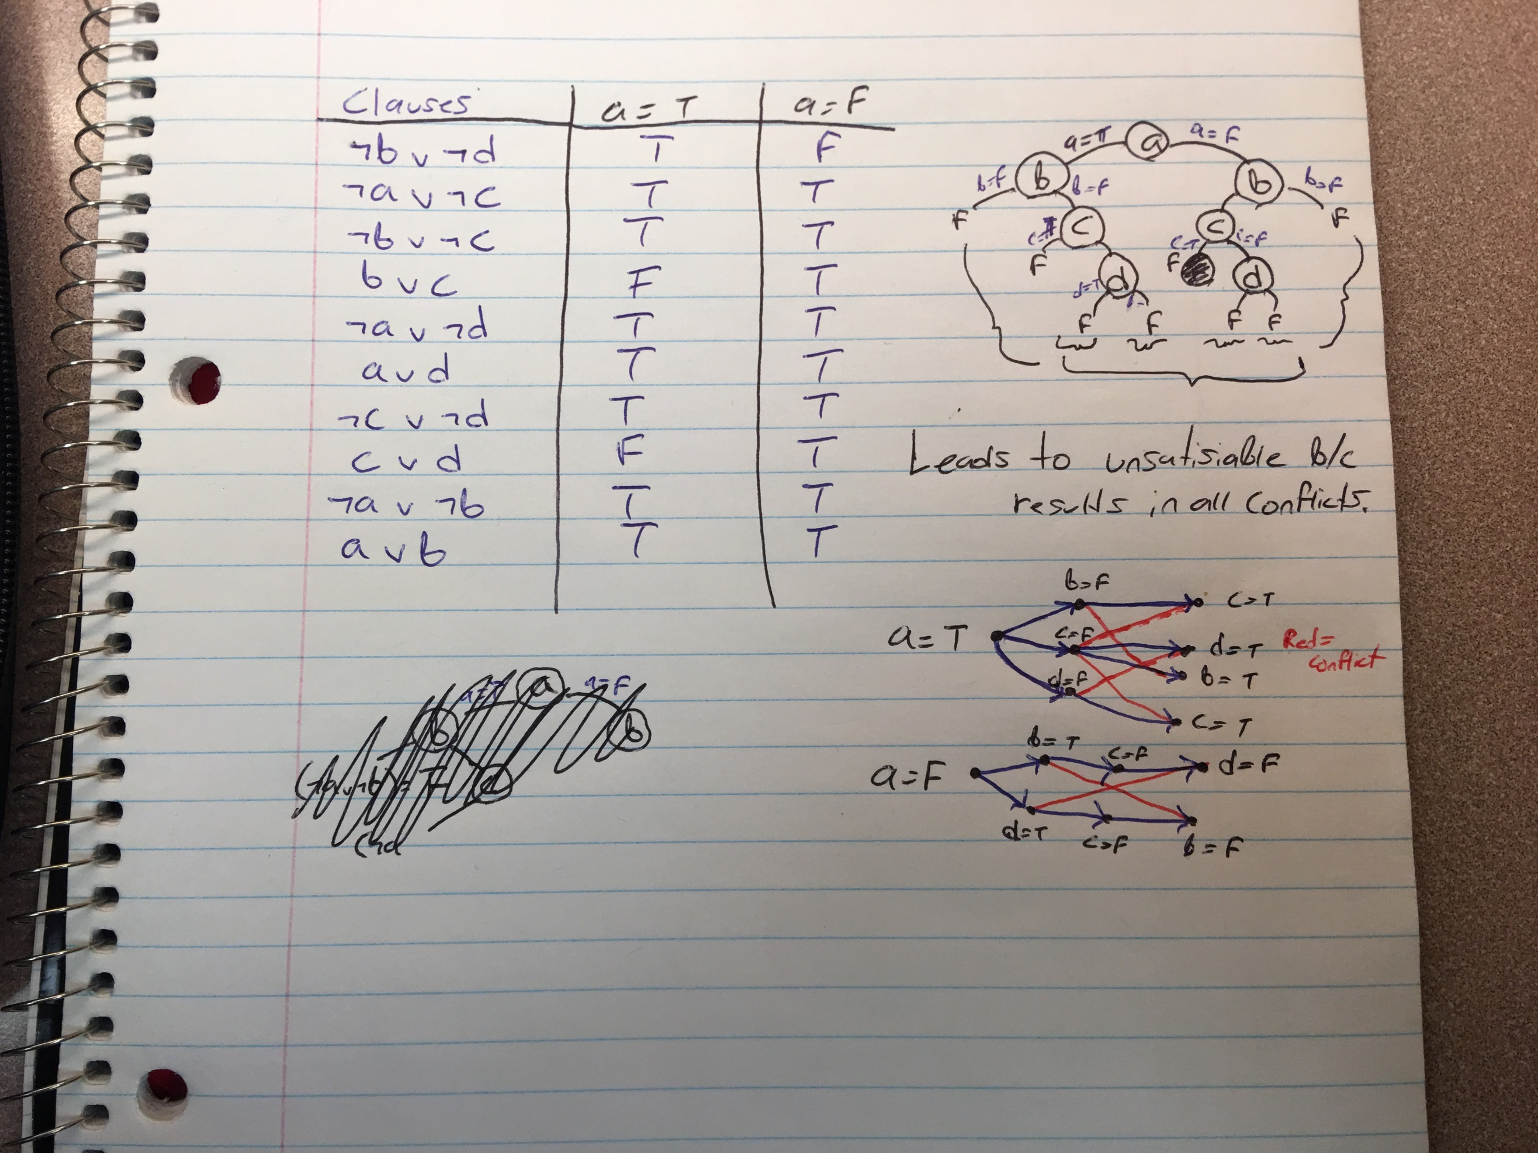

Question 4

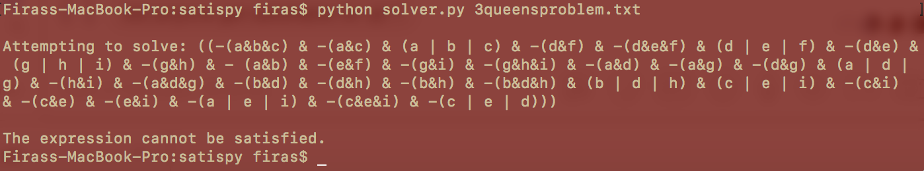

**The answer by the SAT solver is unsatisfiable.**

(text document attached)